Welcome to my portfolio! I created this site to enhance my skills in web development and design, utilizing HTML, CSS, and JavaScript. Throughout this process, I’ve learned a lot of new techniques, and I've spent time researching and experimenting to ensure the code works exactly as I envisioned.
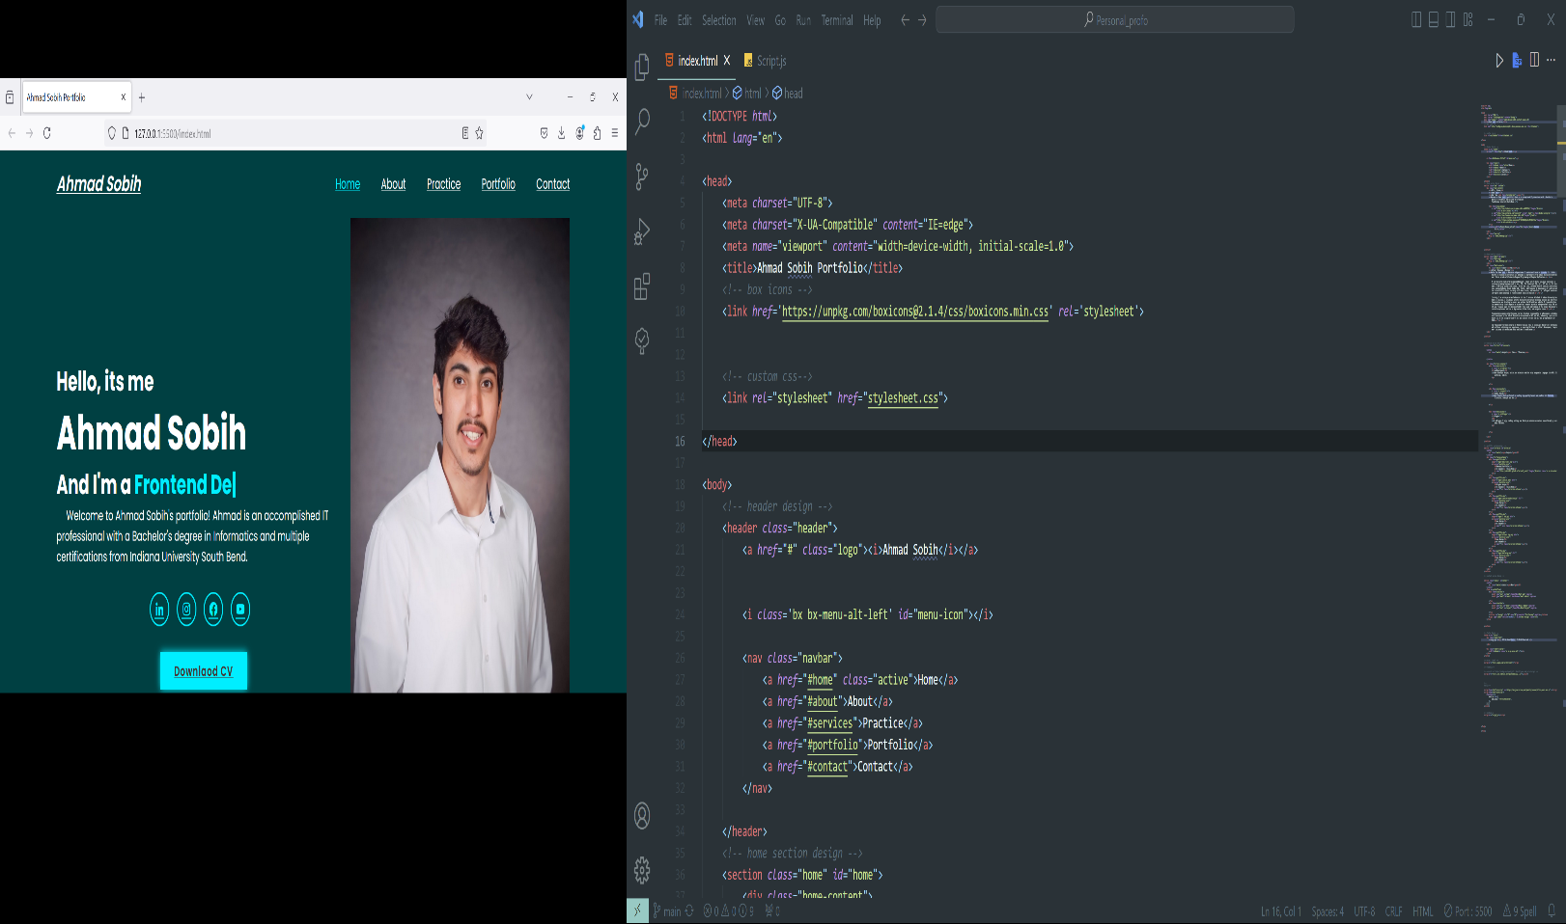

I began by watching a YouTube tutorial to grasp the main concepts and see examples that would help me understand how to start. From there, I built upon that foundation, using Visual Studio Code as my IDE to bring my ideas to life. This portfolio is not just a showcase of my projects but also a reflection of my growth and learning in the field of web development.

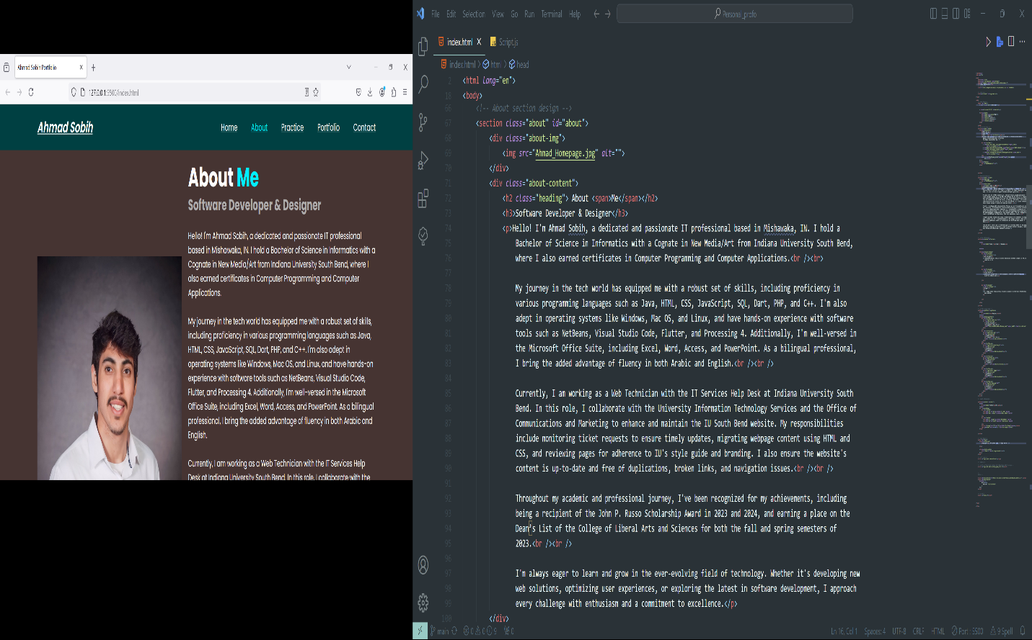
"About" page of a portfolio website for describing my self, a software developer and designer. The page features a professional headshot on the left and a detailed description on the right, highlighting My educational background, technical skills, and current work experience. The site includes a navigation bar at the top with links to different sections of the portfolio, indicating a well-organized layout.

On the right side, the code editor is open to the index.html file, which contains the HTML structure for the "About" page displayed in the browser. The code is neatly organized, with elements for the image, headings, and text content that match the layout seen on the web page. The about section is designed with a div for the image and another div for the text content, which is wrapped in appropriate HTML tags like <h2>, <h3>, and <p>. This setup shows the live connection between the code and its rendered output on the website, showcasing the developer's work on the portfolio's front-end design.

